Planning report

Team members

* Dang Mai Tien Loi (Developer , Scrum Master)
* Dinh Quang Minh (Developer , product owner)
* Geeth Malshika (Developer , Reporter)
* Edwin Changiyoga (Developer , tester)

Product vision

Plantsymbiosis is a mobile application which help for hobbyist gardeners . This android mobile application help for hobbyist gardeners to record and search information about symbiotic relationship between plants and other biological organisms anytime and anywhere. Such as mutualistic , parasitic , competition and commensalistic . This android mobile application also suggesting designs based on a set of plants for design the gardens. Plantsymbiosis mobile application main goal is to support hobbyist gardeners for productive gardens.

Use Case

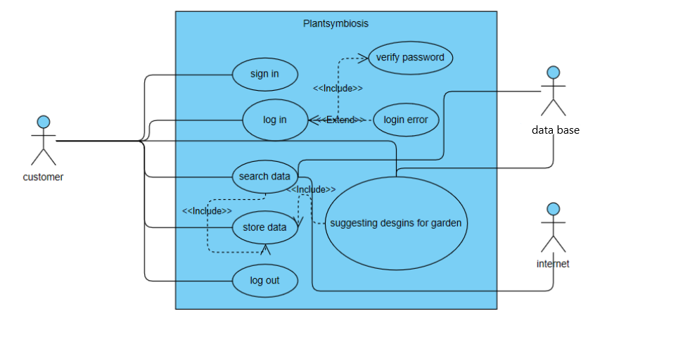

User stories

AS a hobbyist gardener I want a app for my android smart phone so I can use this app whenever and wherever I want.

AS a hobbyist gardener I want make the distinction between different symbioses so I can have a super productive garden without spending a lot of time and a lot of effort.

AS a hobbyist gardener I want to record the name of the plant , a description of it , favourable light , soil and watering conditions , maximum production in grams per plant also I want to upload a picture of it in my android photo gallery.

AS a hobbyist gardener I want to record the type of the symbiosis , the pair of plants and the advantages / disadvantages and a comment so I can search the information when I want.

AS a hobbyist gardener I want a user interface which help me to record , edit , read or delete plants and symbiosis also I want a text input search so I can use it easily.

AS a hobbyist gardener I want a mobile application which give me a textual proposal about to design the garden based on a set of plants.

Product backlog

* Install the software that need for build the application.
* Research about the information that in the user stories.
* Check with the product owner and estimate the time frame for each step in the user stories.
* Create the app using android code.
* Create the data base for application.
* Coding the user interface for the application which help for read , record , edit ,delete and search information.